Guess What’s Coming?
At all Weekend Masses of October 24th
Walking With Moms in Need - A Year of Service
Is Hosting a Baby Shower
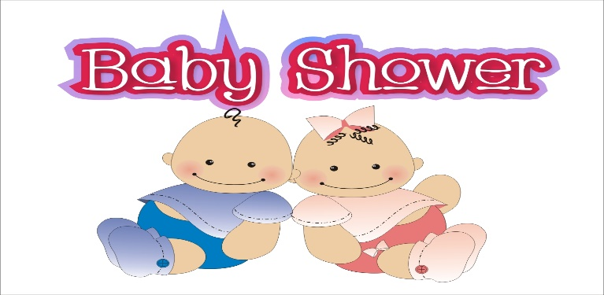

To Benefit
Life Connections & St. Vincent DePaul
Items needed
Diapers esp. larger sizes - Baby Toiletries
Clothing -Sleepers, Booties, Socks, Layettes
Baby wipes, Bottles, Pacifiers, Formula
Gently used and new Clothing, Formula
Gift cards to Supermarkets, Walmart, Target, Costco
All monetary donations gratefully accepted.

