Casting Nets Ministries, a non-for-profit lay apostolate, is a refreshing look at evangelization and catechesis. Casting Nets is dedicated to the challenge of the New Evangelization. Our ministry is to be a resource for individuals, organizations, and parishes who want to answer the challenge of the New Evangelization. Tony Brandt and Chris Stewart have over 40 combined years of experience in almost every level and form of ministry, from the youth to college, and from RCIA to adult formation. They have applied their unique approach to ministry with astonishing success and in a variety of settings, including retreats, lecture series, key notes at conferences, and the classroom. NOW they are taking their ministry to the airwaves and to a town near you.
Chris Stewart
Chris Stewart is a loving husband, father, and dynamic speaker who has engaged youth and adults with captivating talks for over 20 years. He and his beautiful wife, Maria, have been married for 20 years, homeschool their seven children, and live in Wichita, Kansas. Chris’ experience with youth, family life and death, and his ability to connect with his audience no matter what age or walk of life, has made him a sought out speaker for years.

His experience in youth ministry and public speaking began in 1996 when he first taught for Totus Tuus, a summer youth catechetical program. He discovered his gift of speaking and has continued throughout the years giving countless talks in the areas of catechetics, theology, spirituality and evangelization. Chris also taught Religion at Kapaun Mt. Carmel Catholic High School in Wichita from 2005-2015. Now Chris is working to teach all that he encounters how to be the most effective evangelists.

Chris earned his Masters of Theological Studies from the Institute of Pastoral Theology of Ave Maria University. His experience is widespread and includes teaching in elementary, high school, and college settings; youth ministry. He has a gift for bringing his audience to laughter and tears from experiences in his own life.
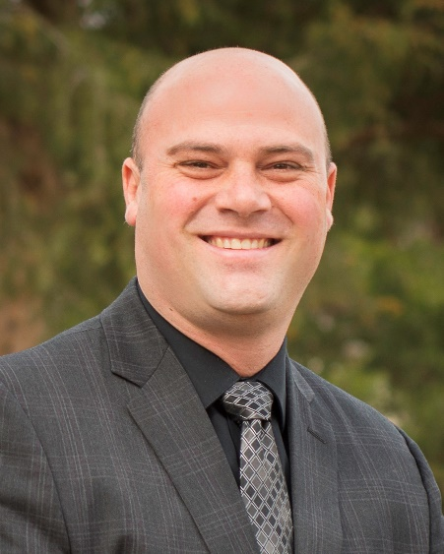
Tony Brandt
Tony Brandt is a dedicated husband and father of seven, who has been inspiring audiences young and old for almost 20 years. He has spent the last 18 years married to his beautiful wife Kelly raising their seven children in Wichita Kansas. His many experiences of being raised in a large adoptive family and helping many people in need over his life, arms him with stories to captivate any audience. His talks are not only inspiring and challenging but also exiting and entertaining making him a speaker many hire to come back year after year.

His public speaking and youth ministry began with teaching for Totus Tuus a summer youth catechetical program in 1997. Tony is taught religion at Bishop Carroll Catholic High School in Wichita Kansas from 2000-2010 and at Kapaun Mt. Carmel Catholic High School also in Wichita Kansas from 2010-2015. Now his full attention in spent training people all over the nation to engage in the New Evangelization.

Tony earned his degree in Religious Studies, Philosophy and Youth Ministry from Benedictine College in 2000. He has had his hand in many areas of ministry and teaching. He has been involved in parish youth ministries and PSR programs as well as teaching at both the high school and college levels. He continued this experience for many years giving countless talks on everything from Apologetics to Catholic moral doctrine, from how to better affect youth to how to live as a Catholic Family. He uses his heart wrenching and gut wrenching experiences to give passionate talks that tend to "hit home" and help people realize the intensity of God's love for them.

